**Strings in Python**

General things to know:

* So far, we have primarily focused on numeric values, specifically integers, when working in Python
* Strings are another variable type that includes letters/characters, words, phrases, or even entire files of text
* Strings can be defined using either single or double quotes, there is no difference in how Python views the two
* Variables can be set to strings using the str() function in python

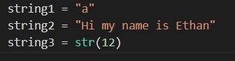

* Strings are essentially a list of characters that make up a word or phrase, each character in a string can be accessed in a manner similar to accessing elements of a list

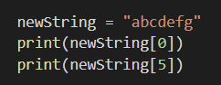 

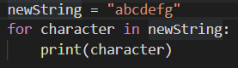 

* Strings also have many of the same built-in functions that allow for getting information about lists, including some that are more relevant to strings

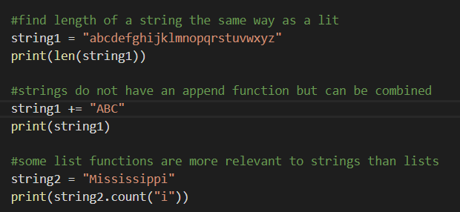

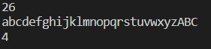

* Additionally, subsections of a string can be isolated using square brackets and the indices of the start and end values

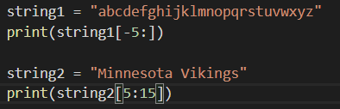 

* One very commonly used string function is the split() function, which separates a string into a list of substrings split at a given character – the default is a space
* The join() function does the opposite of split – rejoins a list of strings into a single string

